Bonrix Software System

- NDNC Filter Guide.

Basic Operations:

- Installation steps for NDNC Filter:

Installation steps are given at the http://www.bonrix.co.in/wiki/Wiki.jsp?page=BonrixNDNCFilter

Main Page:-#

- This is main page of Bonrix NDNC Filter software. It has menus like Users, NDNC, Filter, MobileNo, Mobile Series, Count, Search, Settings....

Groups (Users->Groups):-#

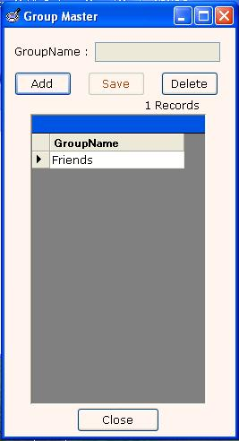
- Using the Groups this You can Add Groups by just clicking on Add button and to save Group Click on Save Button and for delete Groups click on Delete button.

Contacts (Users->Contacts):-#

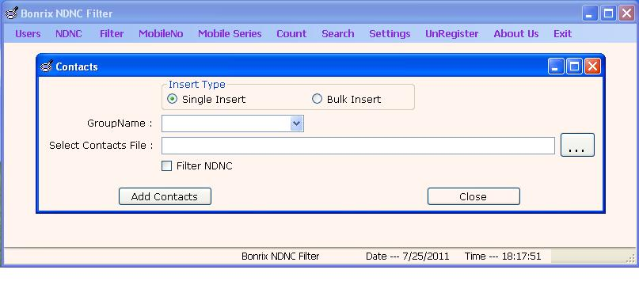
- You can insert contacts directly from the file to particular group and to filter NDNC contact just check the Filter NDNC.

Contact Info (Users->Contact Info):-#

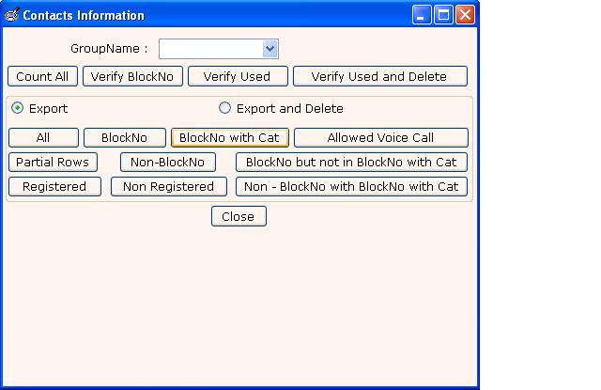

You can fatch Contacts Information first step is to select the perticular group
- Count All - To count total member in the group.
- Veriry Block Number : For total info about group like how many no . in DNC and How many in Allowed Voice Call etc…
- Veryfy Used: This button give info about the number which is previously used or not.
- Verify Used And Delete: This button deletes used numbers from particular group.
- Export : To export from particular group.
- Export And Delete : export from group and delete exported number.
- All : export all number form group.
- Block Number: export Block Numbers form group.
- Block Number with Category: Export Block number with category (e.g. eduction, helth, etc..) from group.
- Allowed Voice Call: Export Allowed voice call (which are de-registered form nccp website ) from group.

Service Areawise Contact (Users->Service AreaWise Contact):-#

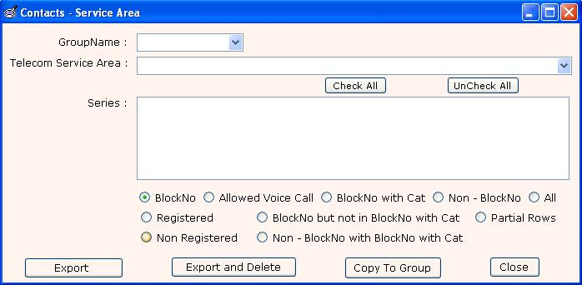

- To retrieve Service Area wise information select service area and group.
- Export - To export NDNC(Block Number,allowed voice call , Block Number with Cat, Non-Block Number, All , Registered etc…) as per service area.
- Export and Delete - To export NDNC(Block Number,allowed voice call , Block Number with Cat, Non-Block Number, All , Registered etc…) as per service area. And delete that numbers from group.

Process TRAI csv (NDNC->Process TRAI csv):-#

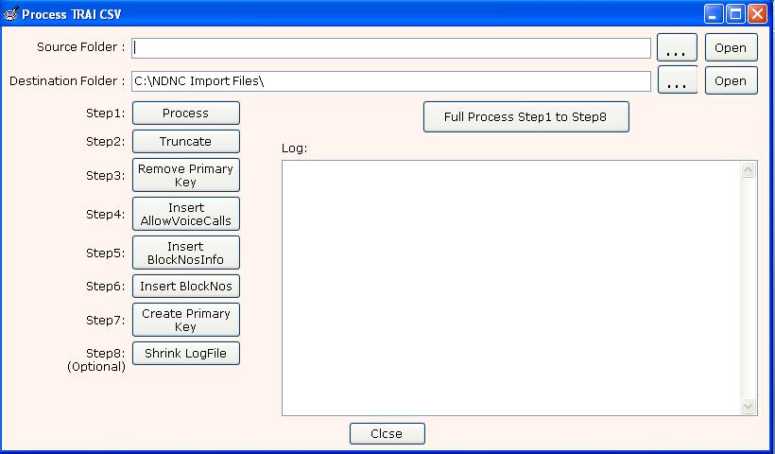

- Using this functionally you can convert TRAI csv into three separate csv like Block Number, Allowed Voice Call, Block Number Info. To do this just give source and destination folder name which you want to convert.\
- Click on full process step 1 to 8
- Remember this is for just first time database creation next time you just need to use Incremental Updates

- It is used to insert TRAI csv file.

(7) Incremental (NDNC->Incremental fast):-#

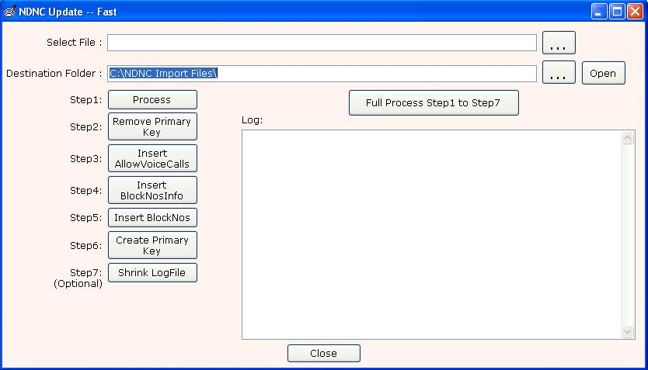
- It is used to update NDNC database.
- Source file as a incremental file which is downloaded form nccptrai.gov.in and destination folder as a any empty folder.
- Click on full process. (this process takes 30- 60 mins)

(8) Delete From(NDNC->Delete From):-#

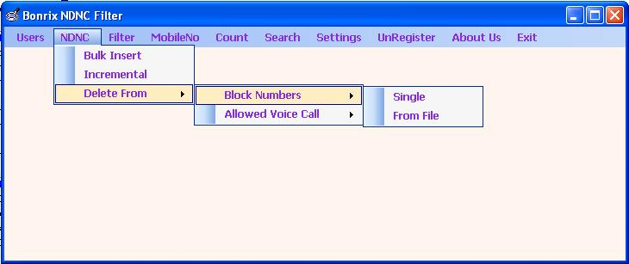
- You can delete Block Number(s) and Allowed Voice Call Number(s).

(9) Delete Single Block Number (NDNC->Delete From->Block Number->Single):-#

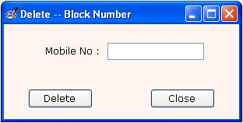
- It is used to delete single block number from NDNC database.To do this just type the mobile number in the text box and press Delete.

(10) Delete Block Numbers form file (NDNC->Delete From->Block Number->From File):-#

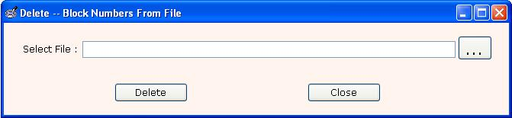
- It is used to delete block numbers from NDNC database.To do this just select the file which you want to delete and press Delete.

(11) Delete Single Allowed Voice Call (NDNC->Delete From->Allowed Voice Call->Single):-#
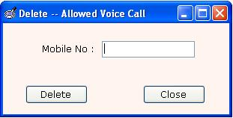
- It is used to delete single Allowed Voice Call number from NDNC database.To do this just type the mobile number in the text box and press Delete.

(12) Delete Allowed Voice Call From Files (NDNC->Delete From->Allowed Voice Call->From File):-#

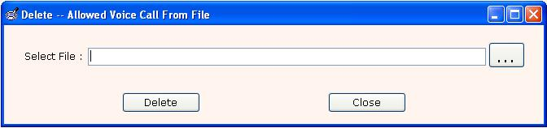
- It is used to delete Allowed Voice Call numbers from NDNC database.To do this just select the file which you want to delete and press Delete.

(13) Filter Allowed Voice Call (Filter->Allowed Voice Call):-#

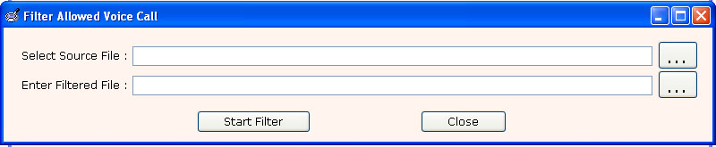
- To filter the Allowed Voice Call Numbers(number which are de-registered form nccp website) give the source file path and give destination file path and press Start Filter(only .txt, .csv and .xls files are allowed).
- Output is filtered Allowed Voice Call Numbers on which you can make Voice Campaign.

(14) Filter Allowed Voice Call MultiColumn (Filter->Allowed Voice call MultiColumn):-#

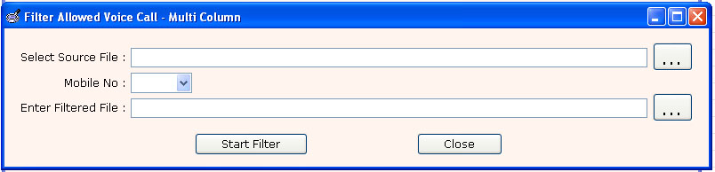
- To filter Allowed Voice Call MultiColumn (source file contain multiple column) select source file and choose column in which Mobile No. resides and select destination file and press Start Filter(only .txt, .csv and .xls files are allowed).
- Output is filtered Allowed Voice Call Numbers.
- Allowed Voice Call Numbers are those numbers on which you can make Voice Campaign/SMS Campaign.

(15) Filter Block Numbers (Filter->Block Numbers):-#

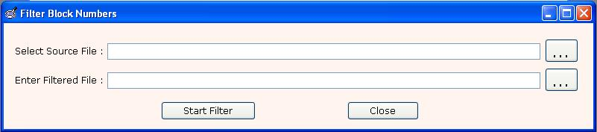
- To filter the Block Numbers give the source file path and give destination file path(just give name with extension like .xls or .csv ) and press Start Filter(only .txt, .csv and .xls files are allowed).
- Output is filtered Non-NDNC Numbers and second file is blocked numbers.
- Non-NDNC numbers are those on which you can make SMS Campaign.

(16) Filter Block Numbers MultiColumn (Filter->Block Numbers MultiColumn):-#
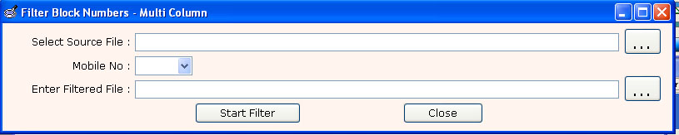
- To filter Block Numbres MultiColumn (source file contain multiple column) select source file and choose column in which Mobile No. resides and select destination file and press Start Filter(only .xls files are allowed).
- For multicolumn file file extension must be .xls
- Output is filtered Non-NDNC Numbers.
- Non-NDNC numbers are those on which you can make SMS Campaign.

(17) Filter Block Numbers Category (Filter->Block Numbers Category):-

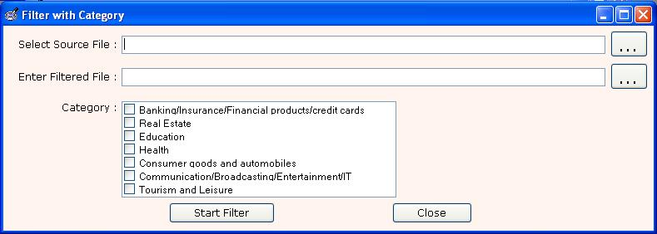
- To filter the partially Block Numbers give the source file path and give destination file path and check on category(ies) press Start Filter(only .txt, .csv and .xls files are allowed).
- Output is filtered partially Non-NDNC Numbers.
- Partially Non-NDNC numbers are those on which you can make SMS Campaign but only on specified category.

(18) Check Block Number (MobileNo->Block Number Check):-#

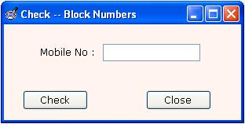
- This functionality is used to Check whether the entered number is Block Number or not.

(19) Mobile Series:-#

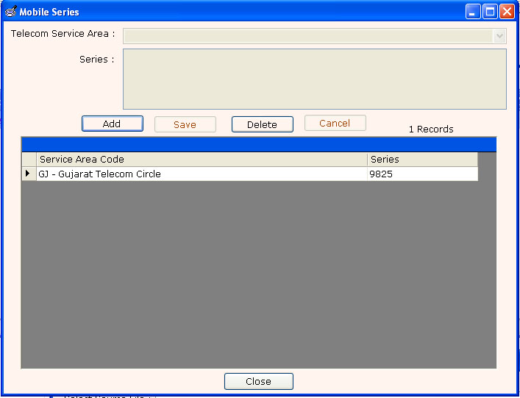

- You can add Telecom Service Area wise Mobile Series(9021,9824,9825..etc).
- Steps for add mobile series.
  - Select Telecom Service Area.
  - Enter mobile series (9021,9824,9825..etc).you can add multiple series using comma(,).
  - Press Save.

(20) Count:-#

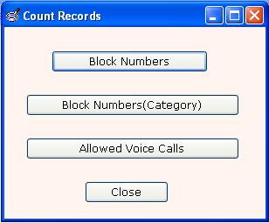
- It is used to count the Phone Number.
  - Block Numbers - To Count Block Numbers form database.
  - Block Numbers(Category) - To Count Block Number(category)(e.g. Health, Real Estate )
  - Allowed Voice Call - To Count Allowed Voice Call Numbers.

(21) Search Category Wise Block Number (Search->Block Numbers With Category):-#

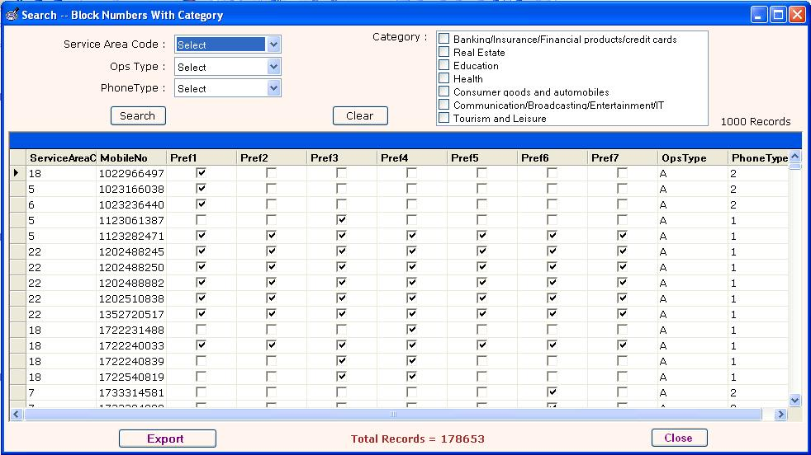
- You can search Partially Block Numbers using this facility.
  - select service area code.
  - Select Opstype.
  - Select phone type.
  - You can also search as per Categories for this check the particular categories as per your requirement.
  - Click on Search button.
- Partially Block numbers are those on which you can make SMS Campaign but only on specified Categories.
- You can also Export Category Block Numbers .CSV Files.

(22) Search Allow Voice Call (Search->Allow Voice Call):-#

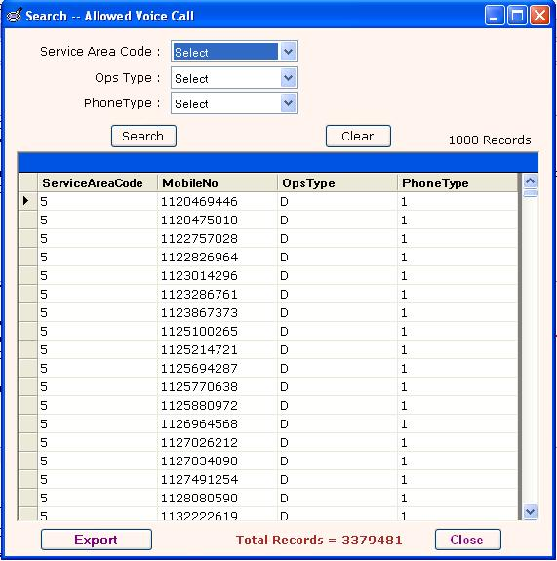
- You can search Allowed Voice Call using this facility.
  - select service area code.
  - Select Opstype.
  - Select phone type.
  - Click on Search button.
- Allowed Voice Call Numbers are those on which you can make Voice Campaign/SMS Campaign.
- You can also Export the partial or full Allowed Voice Call .CSV Files.
  - To Partial Export of Allowed Voice Call click on the Export button and check partial Export give the starting and ending row number.
  - To Full Export of Allowed Voice Call Click on the Export button and check Full Export.

(23) Set Batch Size (Settings->Batch Size):-#

