Bonrix Web Based Scrubbing/Filtering Software

1)Login: User Login To the system through the Valid Username and Password.

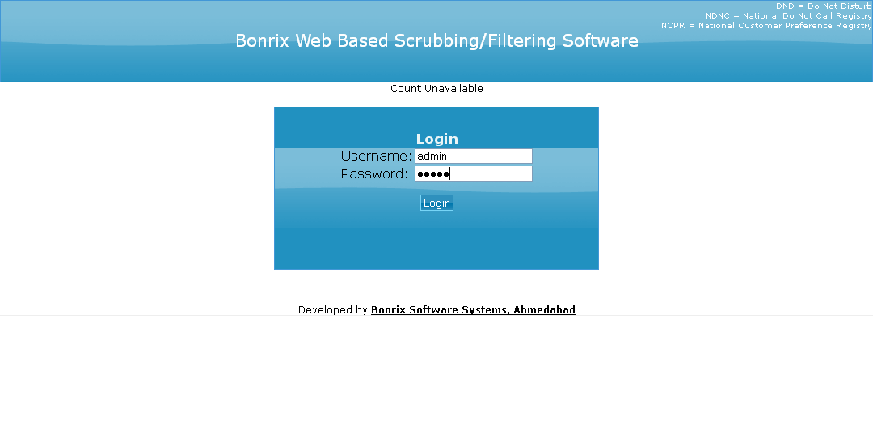

2) Single Number: User Check the Single number which is Registered in the NDNC DATABASE or not.

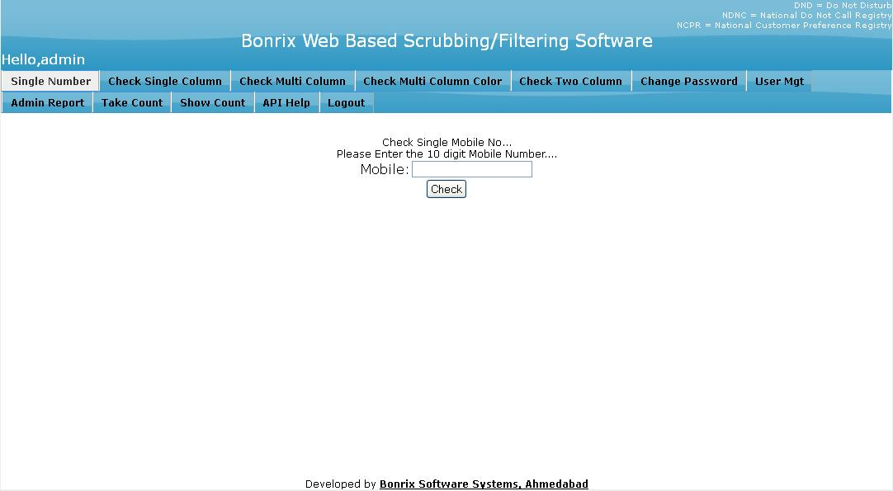

3) Check Single Column: User can Check Single Column File Like .XLS,.XLSX,.CSV and .TXT. And User can Download that file In Output Format Like .XLS,.XLSX,.CSV and .TXT.

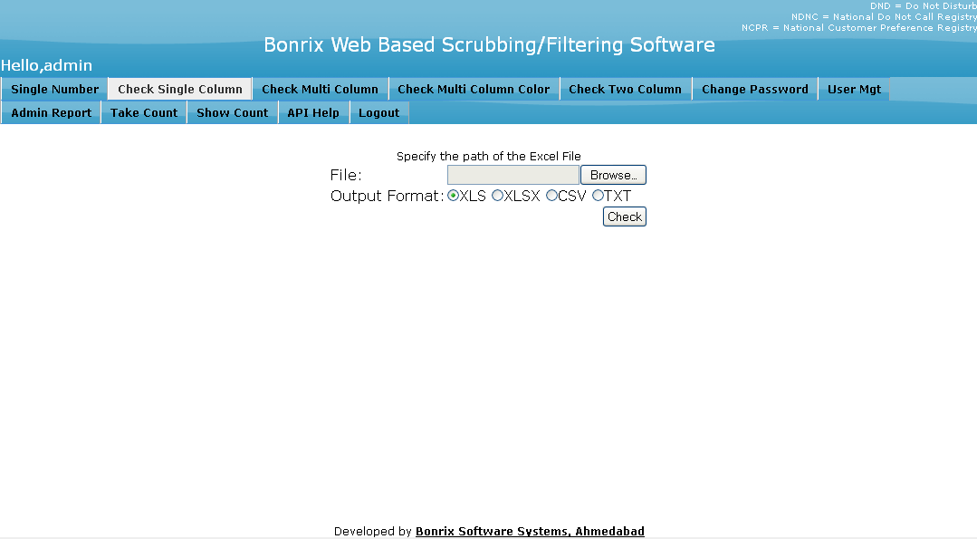

4) Check Multi Column: User can check the Multi Column File which contains more than one column like mobile number, name, address etc. The zip file will be automatically downloaded when user press the check Button containing the files in output format Like .XLS, .XLSX and .CSV.

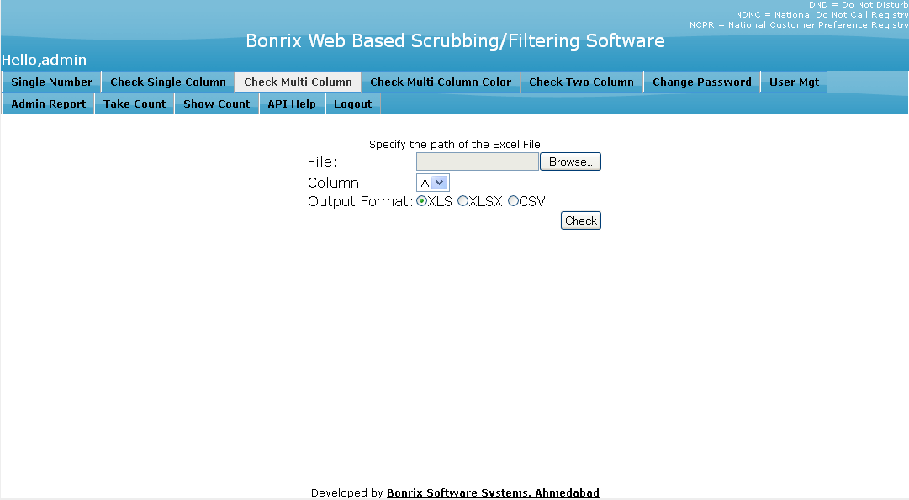

5) Check Multi Column Color: User can check the Multi Column File which contains more than one column like mobile number, name, address etc. The zip file will be automatically downloaded when user press the check Button containing the files in output format Like .XLS, .XLSX and .CSV. The additional feature is the color coded output. Here it will add one more file which contains the data in the color coded output format.

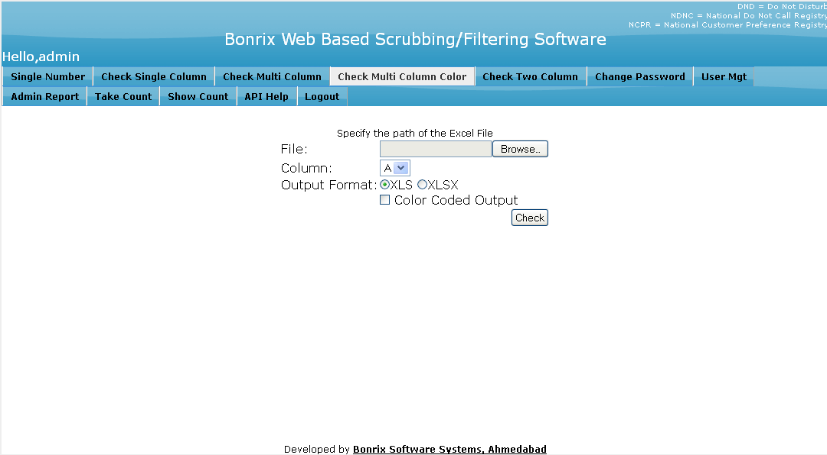

6) Check Two Column User can check the Multi Column File which contains more than one column like mobile number, name, address etc. Here user can specify two columns which contains the mobile numbers. The zip file will be automatically downloaded when user press the check Button containing the files in output format Like .XLS, .XLSX. The additional feature is the color coded output.

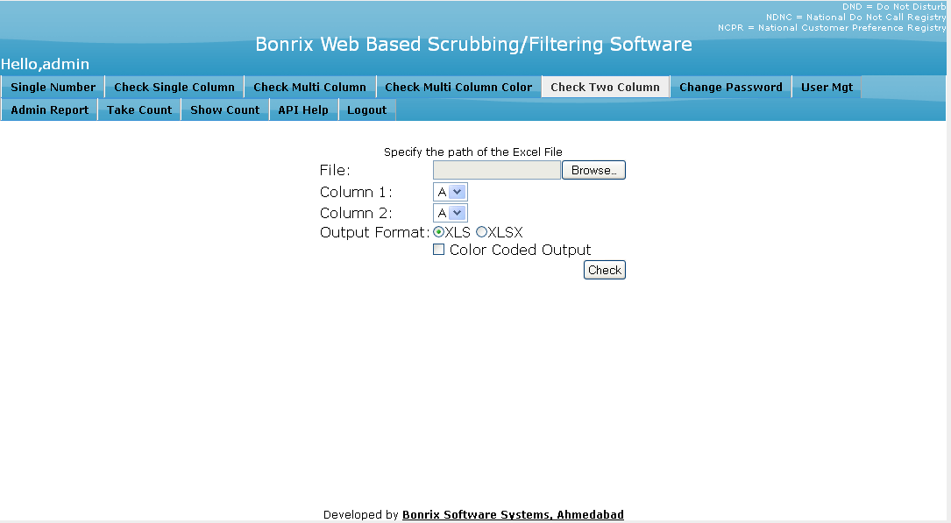

7) Change Password: User can Change His/her Password. In this form user can fill The Current Password, New password and Confirm new Password.

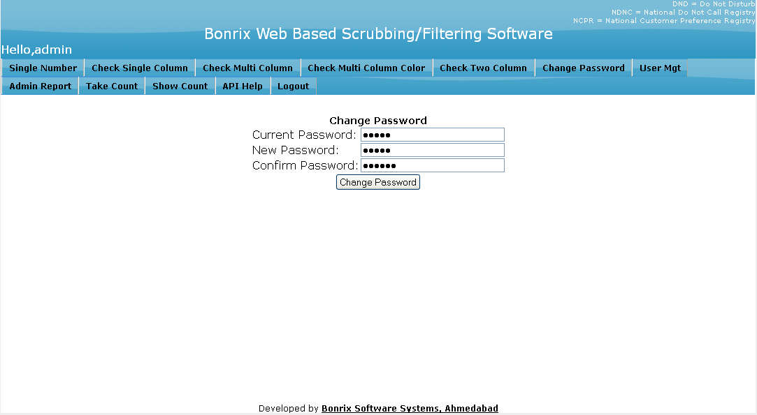

8) User Management: In this Form User can manage the User like Add user, Edit User and Change Password of the user. This feature is only available to admin.

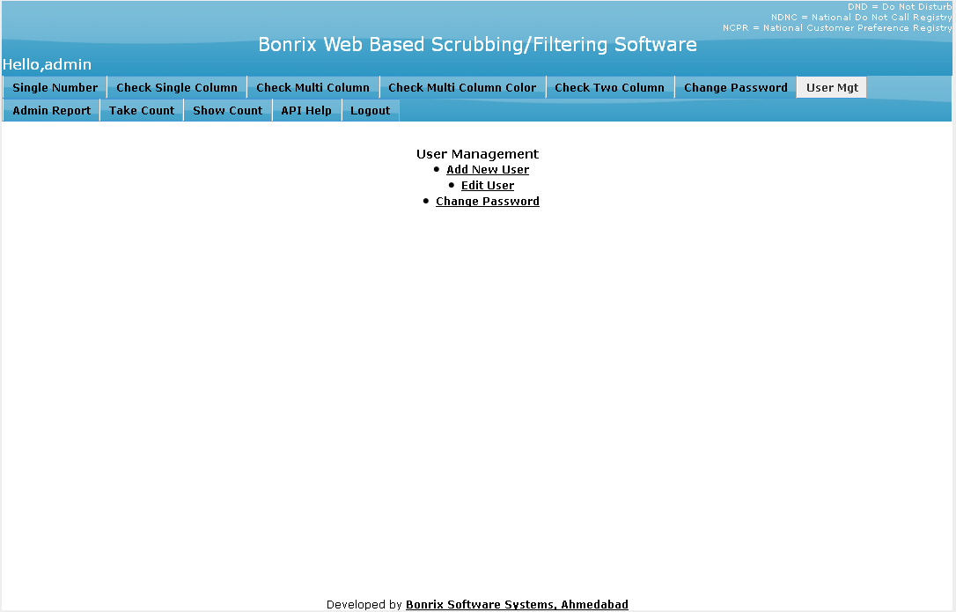

- Add New User: Admin can Add the following Details in to the form to create a new user.

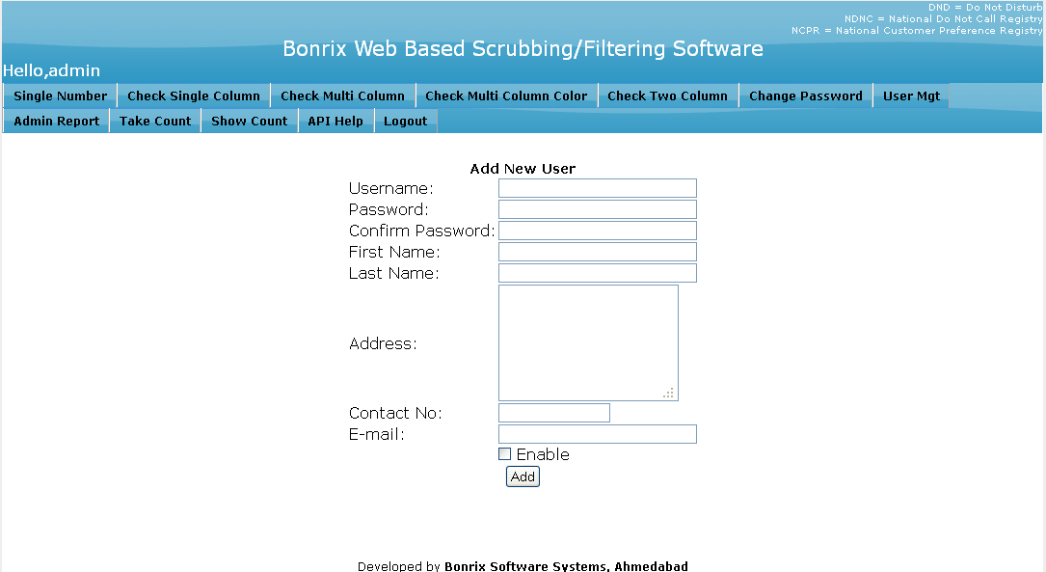

- Edit User : In this form we can Edit the User.

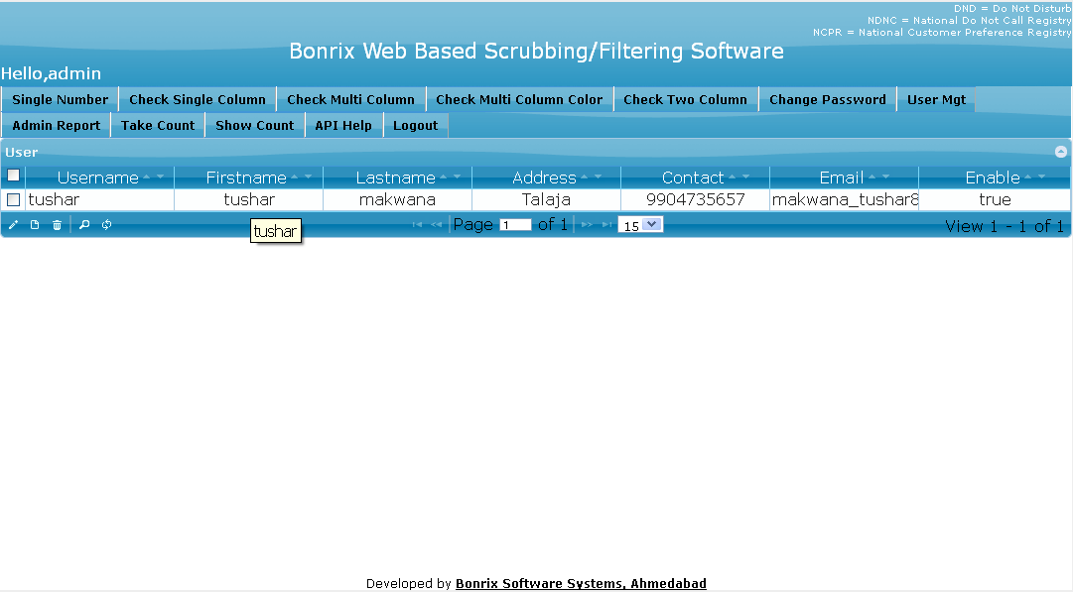

- Change User Password: Admin can Change The password for Particular User.

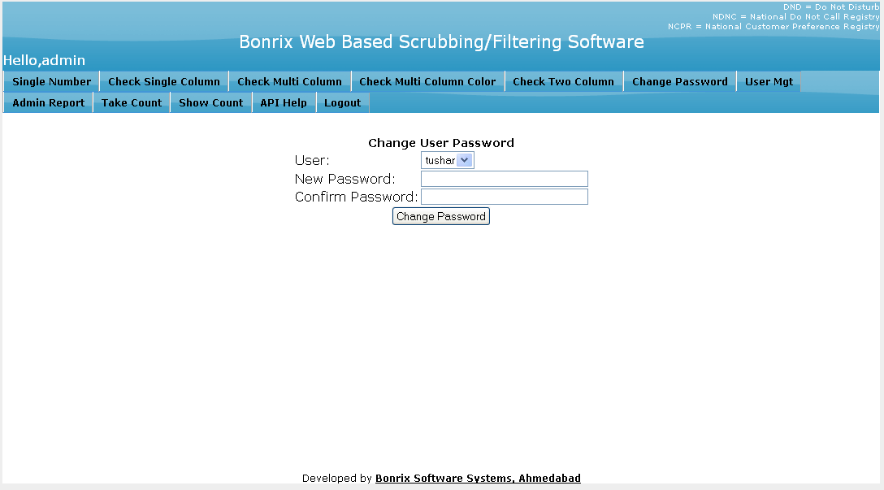

9) Admin Report: Show the Admin Report.

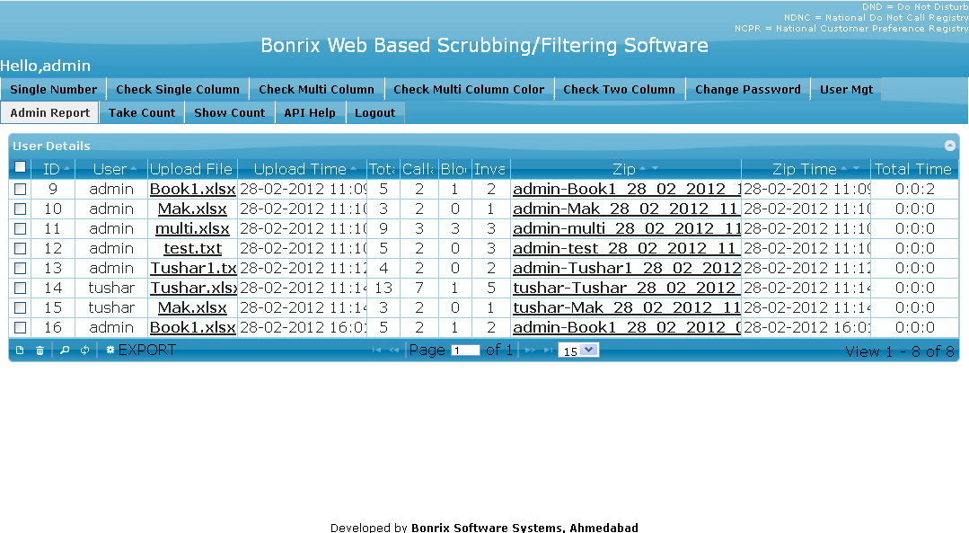

10) Take Count: Take Total Count From The Database. (Available to admin only)

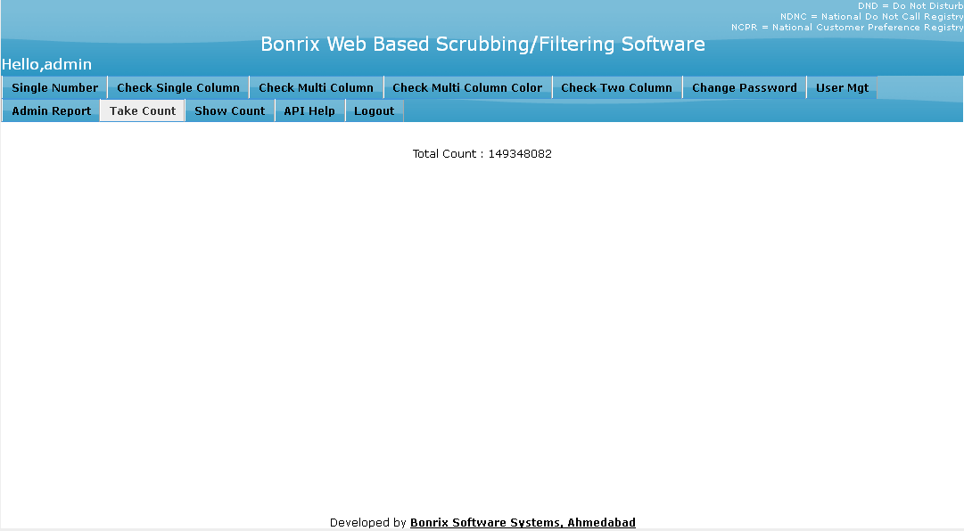

11) Show Count: Display the Count previously taken by the admin. (Available to admin only)

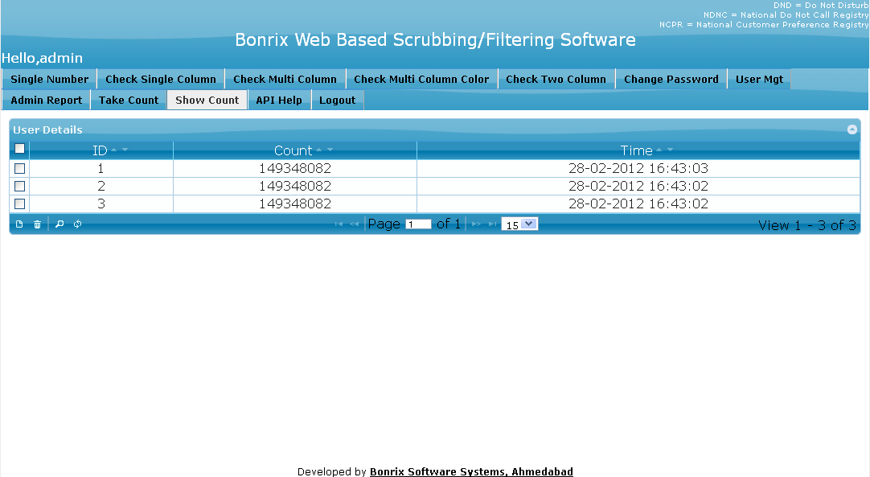

12) API Help: User Direct Access this API .and that API Check The Single Number Which is Registered In to NDNC DATABASE or not.

